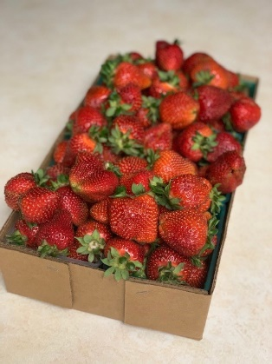
Strawberry Jam
*One small container of strawberries, approximately 2 cups. (wash and cut stem or take off and chop or cut up to small pieces)
*3/4 cup sugar, honey, or sweetener
*2 Tablespoons (TBLS) of lemon juice
Once the strawberries are cut combine all three ingredients into a saucepan. Stir and bring to a slight boil, reduce to a simmer for 20-25 min. Transfer to a jar or container (leave a little space for expansion while in the fridge), put in fridge to chill, or leave overnight, or for the next day. No matter how it turns out, it will still be great on bread or toast.

