* 2 Fruits 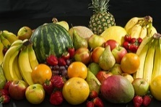
* 2 Vegetables 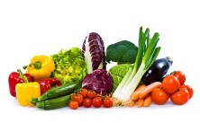
* Flour 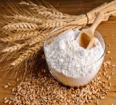
* Cheese 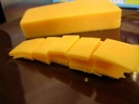
* Measuring Cups 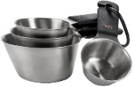

(Fun with the bowl and water)

* Spatula and a Pan 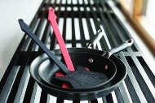

(great for a quick drum set)

* Milk 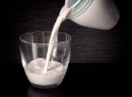
* Bread 

  
  
  
  
  
  
  
  
  