Homemade Butter
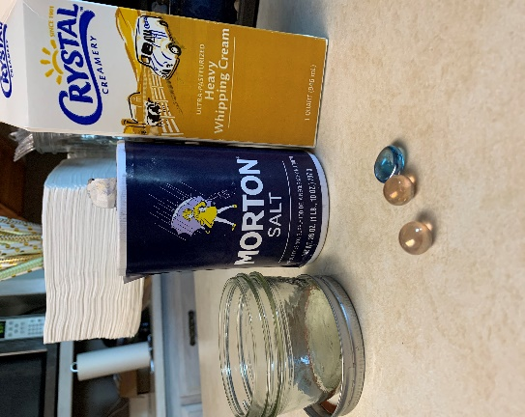
Ingredients
*Heavy Whipping Cream
*Jar with a lid
Optional
*Salt ¼ teaspoon
*Marbles (for agitation and helps the fat stick)

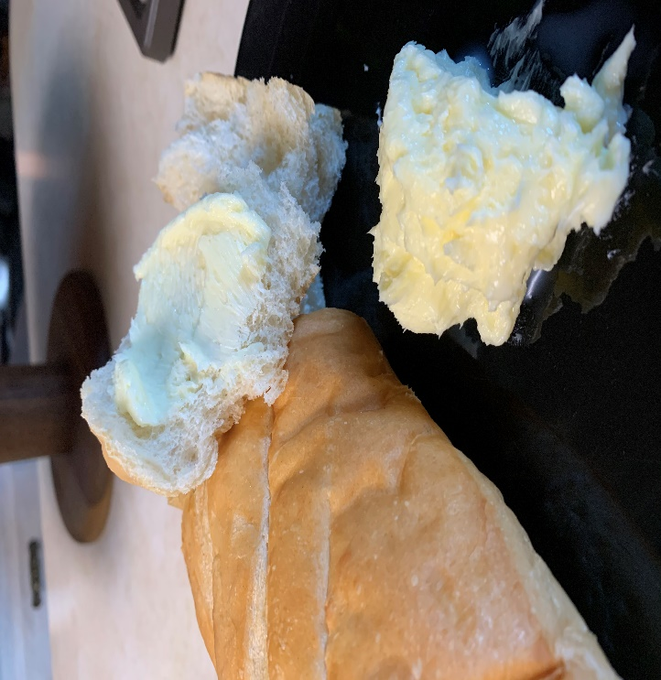
Fill a jar halfway and with heavy whipping cream. Secure with the lid on. Take turns shaking, rolling the jar back and forth, dance with a song, jump, however you can. It will take about 5-10 minutes. It will look like whipped cream, then it will get a little harder to shake and look thick, then it will become a solid and then there will be a solid piece and a good amount of liquid. This is considered the buttermilk and you can save it. Just pour out the liquid and use a spoon to smooth out and round your butter. It’s supper yummy. Watch the video link provided for the YouTube of Ms. Kristina and her kids making this butter.

