August
2020
The Start of the Year
Important dates  Here is the synopsis of the month. We start our first day of our family childcare, August 10th. We will have our first event Saturday August 22nd, at 7:30 pm. We will set up our projector out in the front yard and show a family movie. August 28th we will have our first date night childcare. This is will be by sign up genius, from 5-9 pm we will have dinner and activities, $20 a child, $5 for any additional children for those enrolled. $45 for drop off, up to 8 slots. | 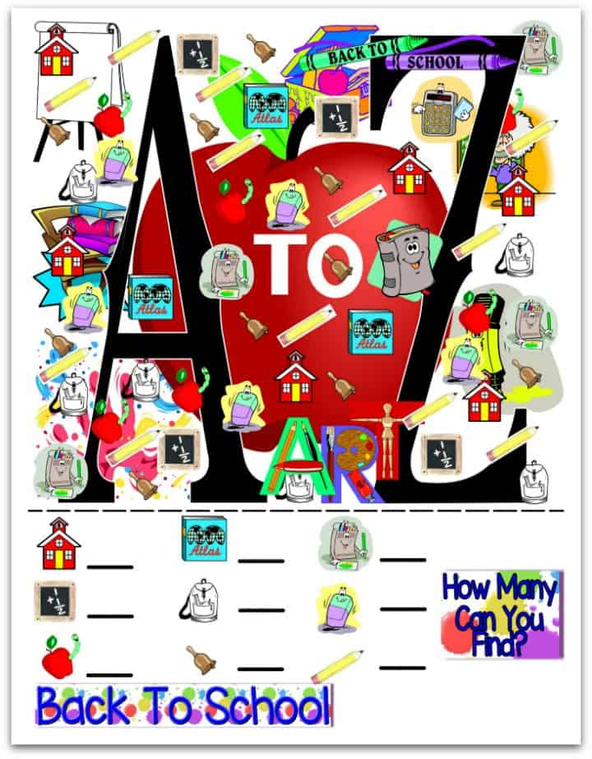
Sunday | Monday | Tuesday | Wednesday | Thursday | Friday | Saturday
 |  |  |  |  |  | 1
2 | 3 | 4 | 5 | 6 | 7 | 8
 |  | Open House | Open House | Open House | Open House
9 | 10 | 11 | 12 | 13 | 14 | 15
 | Grand Opening
16 | 17 | 18 | 19 | 20 | 21 | 22
 |  |  |  |  |  | Family Movie Night. 7:30-9:30pm
23 | 24 | 25 | 26 | 27 | 28 | 29
 |  |  |  |  | Date Night Drop Off 5-9pm
30 | 31

