|  |  |  |  |
| --- | --- | --- | --- |
| Fruit | Spoon | [This Photo](https://commons.wikimedia.org/wiki/File:Bowl_(PSF).svg) by Unknown Author is licensed under [CC BY-SA](https://creativecommons.org/licenses/by-sa/3.0/)  Bowl | Flour |
| Vegetables | Milk  [This Photo](https://urbanveganchic.com/2013/01/10/its-a-dairy-disaster/) by Unknown Author is licensed under [CC BY-NC-ND](https://creativecommons.org/licenses/by-nc-nd/3.0/) | Fork | Cereal |
| Eggs | Measuring Cups | Spatula | Sugar |
| Cheese | Yogurt | Salt | Pan  [This Photo](http://pngimg.com/download/8358) by Unknown Author is licensed under [CC BY-NC](https://creativecommons.org/licenses/by-nc/3.0/) |

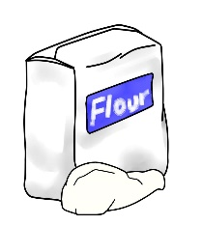

[This Photo](http://sa-jin-gi.deviantart.com/art/Flour-Clipart-402926236) by Unknown Author is licensed under [CC BY-NC-ND](https://creativecommons.org/licenses/by-nc-nd/3.0/)